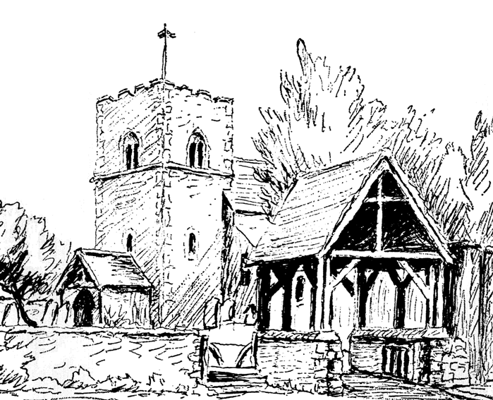
DATA PRIVACY NOTICE

The Parochial Church Council (PCC) of St Peter and St Paul, Rustington

1. Your personal data – what is it?
Personal data relates to a living individual who can be identified from that data. Identification can be by the information alone or in conjunction with any other information in the data controller’s possession or likely to come into such possession. The processing of personal data is governed by the General Data Protection Regulation (the “GDPR”).

2. Who are we?
The PCC of St Peter and St Paul, Rustington is the data controller (Contact details: see end of notice). This means it decides how your personal data is processed and for what purposes.

3. How do we process your personal data?
The PCC of St Peter and St Paul, Rustington complies with its obligations under the “GDPR” by keeping personal data up to date; by storing and destroying it securely; by not collecting or retaining excessive amounts of data; by protecting personal data from loss, misuse, unauthorised access and disclosure and by ensuring that appropriate technical measures are in place to protect personal data.

We use your personal data for the following purposes: -
- To enable us to provide a voluntary service for the benefit of the public in the parish;
- To administer membership records;
- To fundraise and promote the interests of the charity;
- To manage our employees and volunteers;
- To maintain our own accounts and records (including the processing of gift aid applications);
- To inform you of news, events, activities and services running at St Peter and St Paul, Rustington.

4. What is the legal basis for processing your personal data?
- Explicit consent of the data subject.
- Processing is necessary for carrying out legal obligations in relation to Gift Aid or under employment, social security or social protection law, or a collective agreement;
- Processing is carried out by a not-for-profit body with a political, philosophical, religious or trade union aim provided: -
  - the processing relates only to members or former members (or those who have regular contact with it in connection with those purposes); and
  - there is no disclosure to a third party without consent.

5. Sharing your personal data
Your personal data will be treated as strictly confidential and will only be shared with other members of the church in order to carry out a service to other church members or for purposes connected with the church. We will only share your data with third parties outside of the parish with your consent.

6. How long do we keep your personal data?
We keep data in accordance with the guidance set out in the guide “Keep or Bin: Care of Your Parish Records” which is available from the Church of England website [see footnote for link].

Specifically, we retain electoral roll data while it is still current; gift aid declarations and associated paperwork for up to 6 years after the calendar year to which they relate; and parish registers (baptisms, Banns, marriages, funerals) permanently.
7. Your rights and your personal data
Unless subject to an exemption under the GDPR, you have the following rights with respect to your personal data: -
- The right to request a copy of your personal data which the PCC of St Peter and St Paul, Rustington holds about you;
- The right to request that the PCC of St Peter and St Paul, Rustington corrects any personal data if it is found to be inaccurate or out of date;
- The right to request your personal data is erased where it is no longer necessary for the PCC of St Peter and St Paul, Rustington to retain such data;
- The right to withdraw your consent to the processing at any time
- The right to request that the data controller provide the data subject with his/her personal data and where possible, to transmit that data directly to another data controller, (known as the right to data portability), (where applicable) [Only applies where the processing is based on consent or is necessary for the performance of a contract with the data subject and in either case the data controller processes the data by automated means].
- The right, where there is a dispute in relation to the accuracy or processing of your personal data, to request a restriction is placed on further processing;
- The right to object to the processing of personal data, (where applicable) [Only applies where processing is based on legitimate interests (or the performance of a task in the public interest/exercise of official authority); direct marketing and processing for the purposes of scientific/historical research and statistics]
- The right to lodge a complaint with the Information Commissioners Office.

8. Further processing
If we wish to use your personal data for a new purpose, not covered by this Data Protection Notice, then we will provide you with a new notice explaining this new use prior to commencing the processing and setting out the relevant purposes and processing conditions. Where and whenever necessary, we will seek your prior consent to the new processing.

9. Contact Details

To exercise all relevant rights, queries of complaints please in the first instance contact the Parish Administrator at St Peter and St Paul, Church Office, 77 The Street, Rustington BN16 3NL or spsp.office@gmail.com.

You can contact the Information Commissioners Office on 0303 123 1113 or via email https://ico.org.uk/global/contact-us/email/ or at the Information Commissioner's Office, Wycliffe House, Water Lane, Wilmslow, Cheshire. SK9 5AF.

Details about retention periods can currently be found in the Record Management Guides located on the Church of England website at: - https://www.churchofengland.org/more/libraries-and-archives/records-management-guides

